File Processing Guide
How to convert various file types carved from Foremost or produced by Nmap into formats that can be fed into Ollama.

Table of Contents
File Processing Guide 1
KEY 3
PDF 3
Compressed 4
RAR 4
ZIP 4
Images 5
BMP 5
GIF 5
JPEG 5
PNG 6
Office 7
DOCX 7
PPTX 7
XLSX 7

KEY
Command, Variable/Prompt

PDF
-You CANNOT use the cat shell command to read the .pdf directly to the model
-Ollama/Gemma4 have trouble reading large text files
-Use ‘pdftotext’
pdftotext input.pdf output.txt
-then either
cat file.txt | ollama run gemma4:26b examine this file
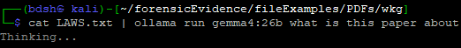
-or
ollama run gemma4:26b examine this file <file.txt
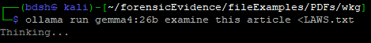
-you can input multiple text files too (doesn’t work yet)
cat *.txt | ollama run gemma4:26b examine these files
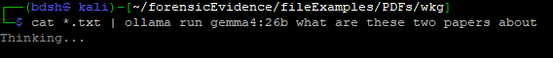

Compressed

RAR
-use ‘unrar’
unrar x file.rar
-can append with a directory to place into
unrar x file.rar extracted/
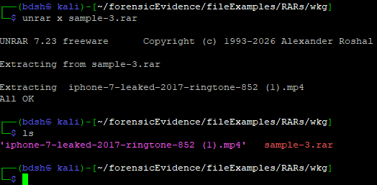

ZIP
-use ‘unzip’
unzip file.zip
-can append with directory flag and directory to place into
unzip file.zip -d extracted/
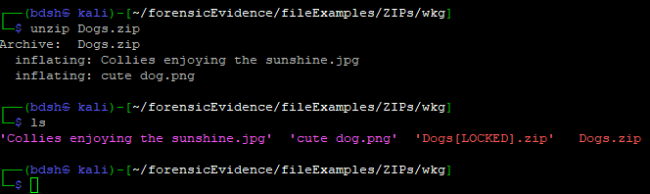

Images

BMP
-Use ‘ffmpeg’
ffmpeg -i input.bmp output.png
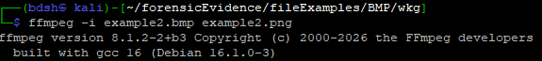
-Then
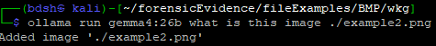

GIF
-The entire GIF could be converted into multiple frames and viewed frame by frame
-Or you could convert a single frame (say the first) with ‘ffmpeg’ to png
ffmpeg -i file.gif -frames:v 1 output.png
-it works but gives some messages
-then
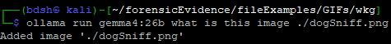

JPEG
-No conversion required
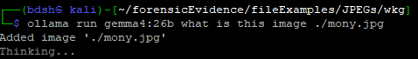

PNG
-No conversion required
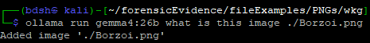

Office

DOCX
-Use ‘pandoc’ to convert a DOCX to a .txt and pipe it directly to Ollama with |
pandoc file.docx -t plain | ollama run gemma4:26b what is this document

PPTX
-Use ‘pandoc’ to convert a PPTX to a .txt and pipe it directly to Ollama with |
pandoc file.PPTX -t plain | ollama run gemma4:26b what is this presentation
LIMITATIONS
-Cannot view images

XLSX
-Use ‘ssconvert’ to convert an XLSX to .txt
ssconvert file.xlsx file.txt
-Then either
cat file.txt | ollama run gemma4:26b examine this file
-or
ollama run gemma4:26b examine this file <file.txt

Nmap

XML
-‘Cat’ the XML and pipe it directly into Ollama
cat nmapScan.xml | ollama run gemma4:26b Examine this Nmap scan

